1. Customers Registration and payment

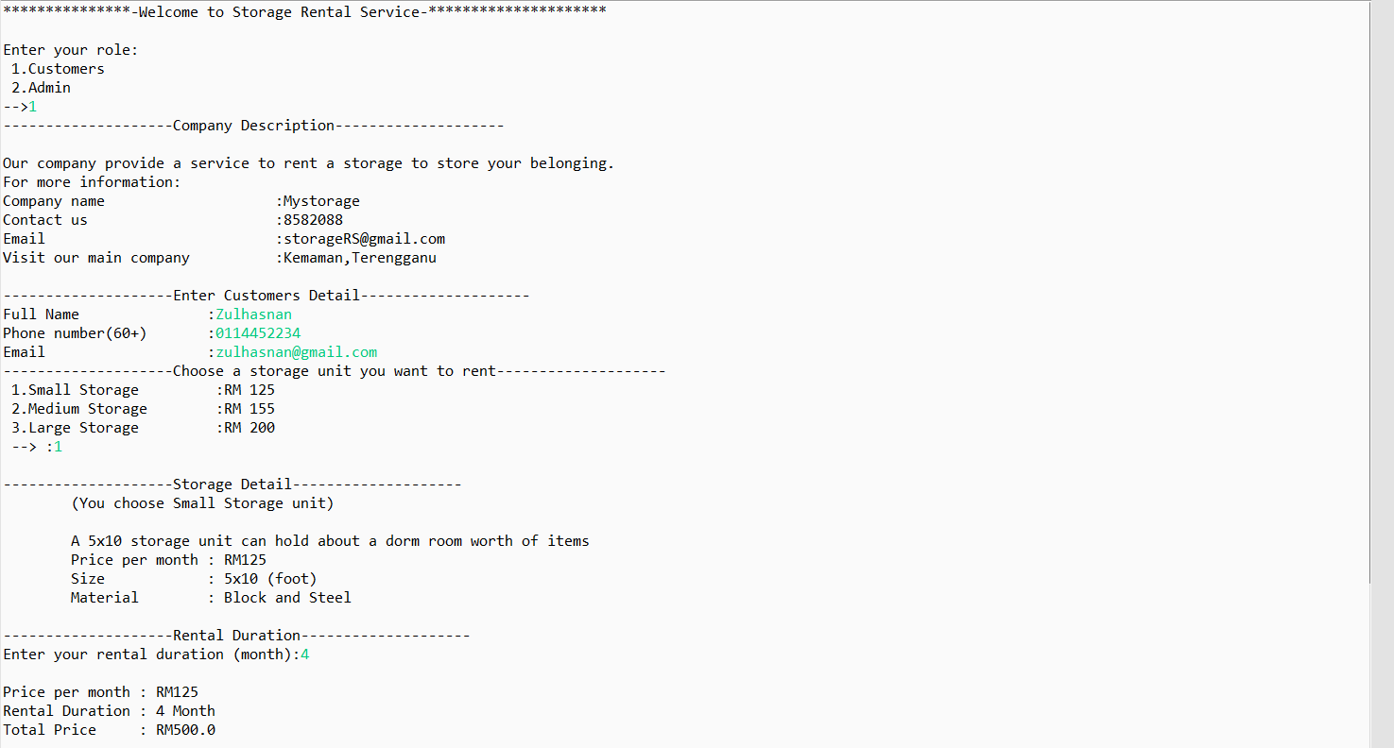

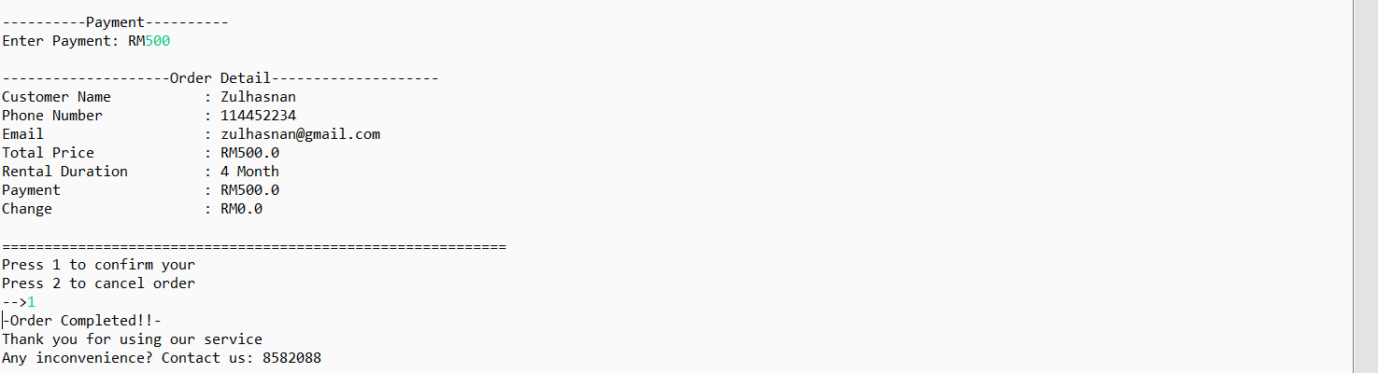

1. Customers cancel order

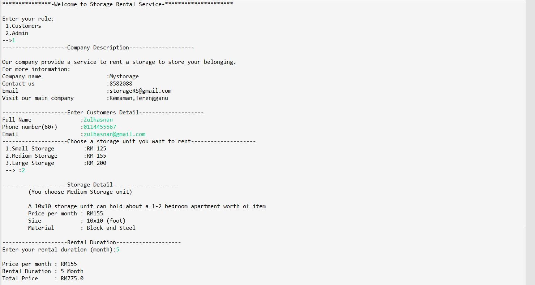

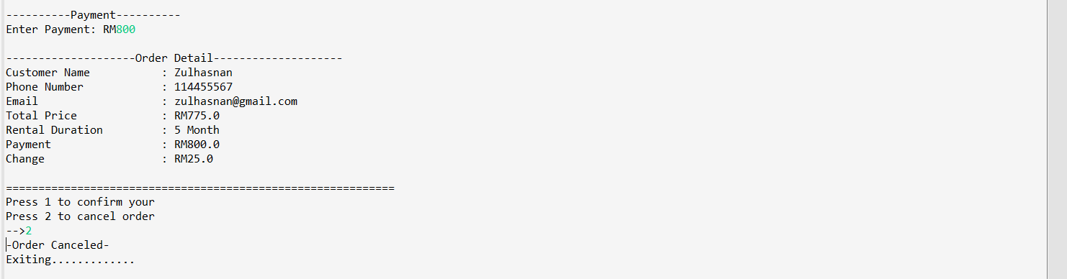

1. Admin (Wrong username or password)

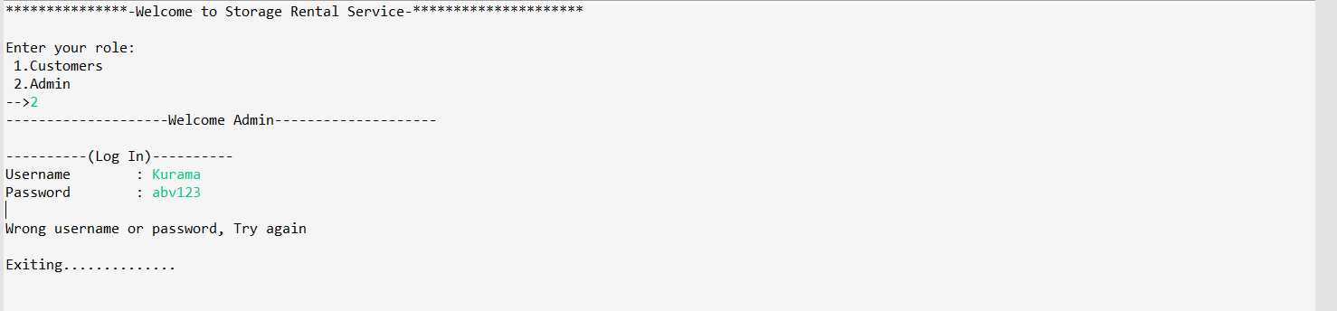

1. Admin (Employee Information)

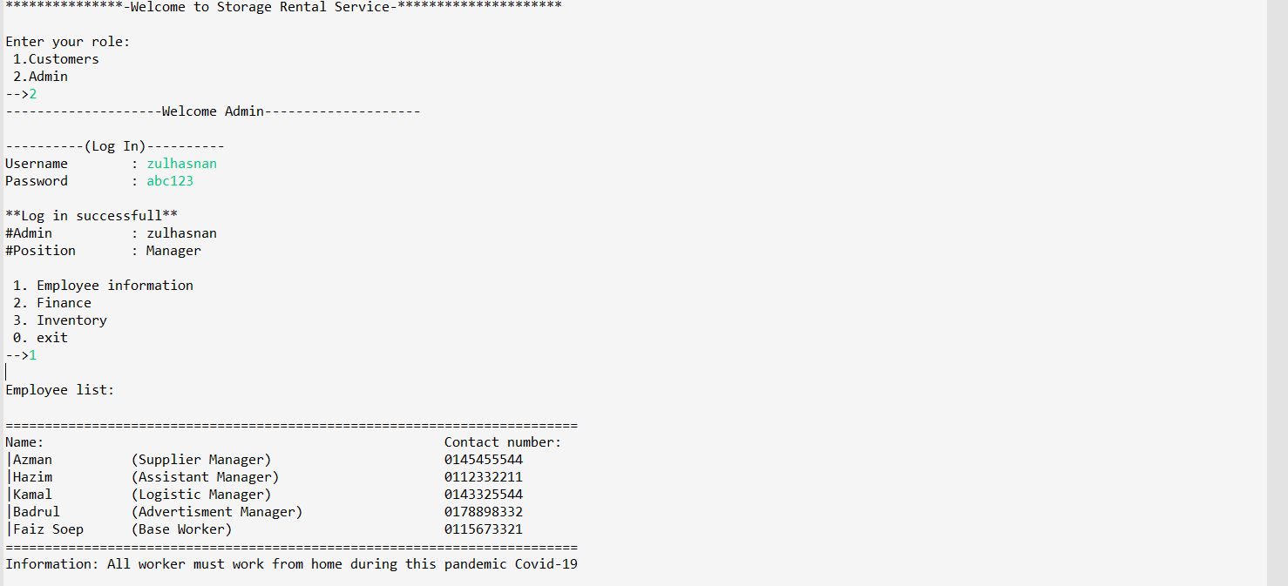

1. Admin (Financial)

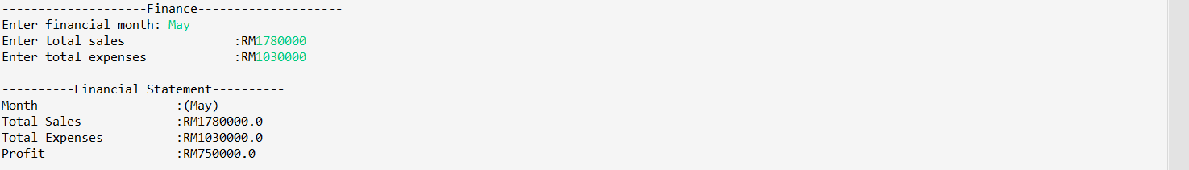

1. Admin (Inventory and Exit)

